**PROJECT 1**

**GROUNDNUT FARMING**

# **THE BEGINNING**

Getting the groundnut seeds together from a local store for the purpose of experimental planting.

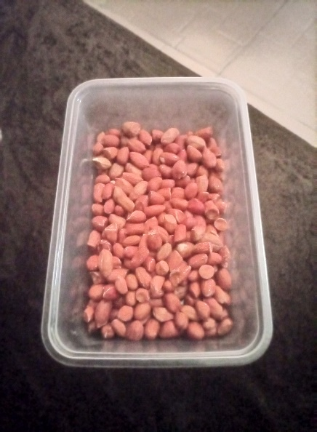

Carefully collect some portion of the groundnut seeds for the experimental planting to ascertain the growth and the type of soil that it will thrive.

The next thing to soak the groundnut seeds in a bow of water for about 6-8hrs. This act is to soften the seed for potential growth.

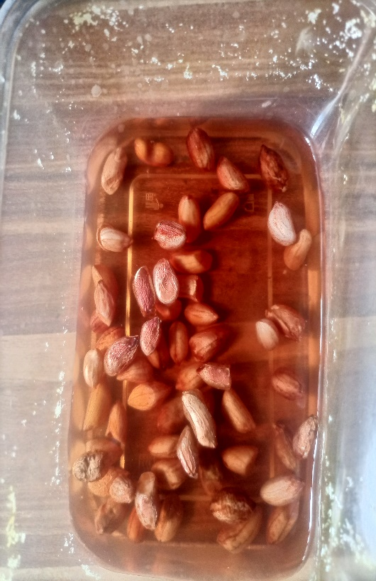

(6-8hrs in the bow filled with water (H20)

# **THE INCUBATIVE PHASE**

This phase of the project is to observe the early growth stage. The phase also give the viable seeds appearance when germination. This phase is done after filtering or collecting the seed from the bow of water.

The flat surface bow is needed. A soft paper is place on the ground floor of a bow and place the seeds gently on the bow and cover with the soft paper. Immediately, this is done sprintle water on the top of the cover bow. The below image illustrate better understanding

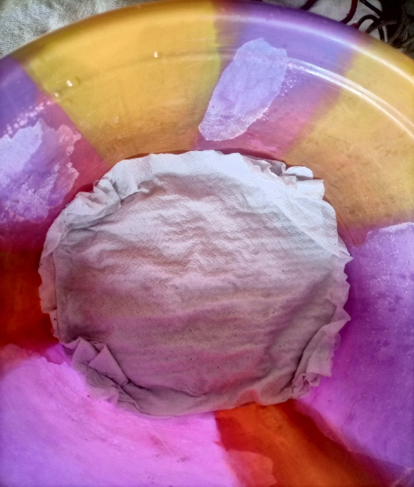

# This practice is done to enable early growth of the groundnut seeds and also see which seeds are not healthy or viable for planting. This phase of covering the groundnut seeds and watering it each days (Morning and evening) for 1-3 days.

0

On the third day, remove the soft paper from the top. The below is what you will SEE

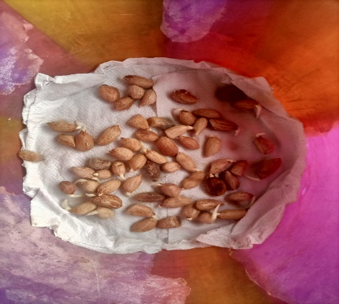

If you observe well, you will notice some of the seeds growing already. That show that those seeds are viable and healthy. After separating the healthy seeds from the non-healthy ones, the healthy ones are place on the port as seen below

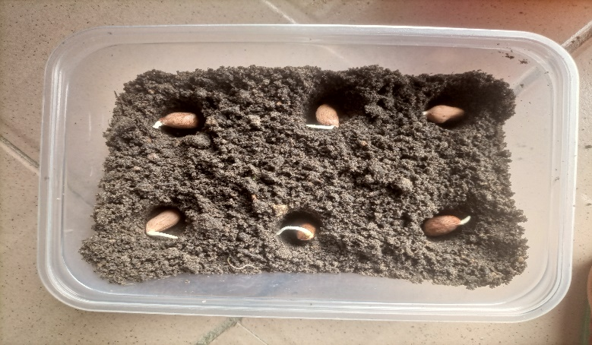

Note: The growing seeds are already place on the port hole and then cover up with earth. As a seen below

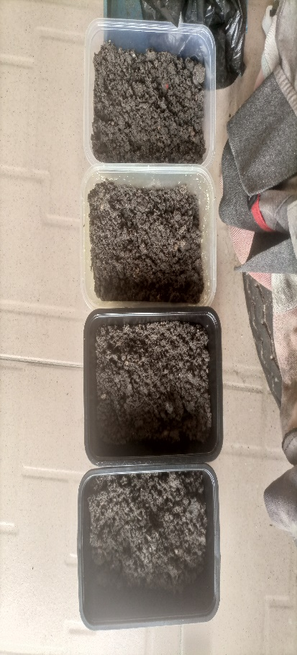

After covering the seeds with earth, it was then watered and observe closely. The watering of the plant seeds are done early in the morning (6:00am), late (5:00pm) in the evening.

# The Early Growth

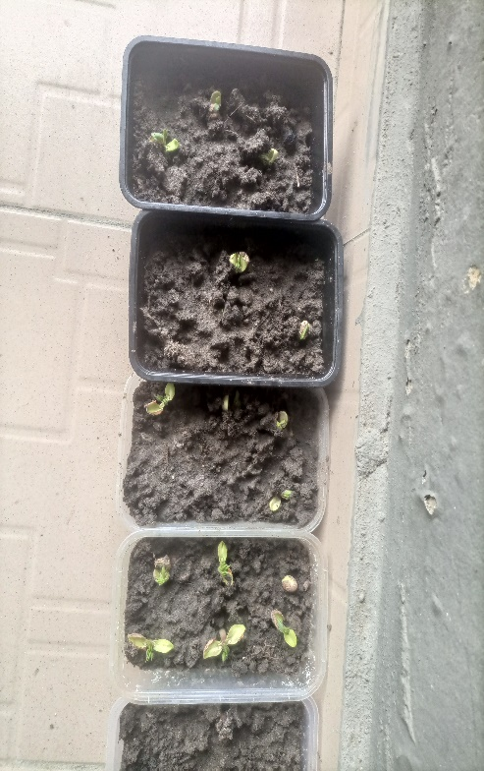

After 3days of planting the seeds, its sprout well and healthy showing positive signs of growth. The growing stage in day 5 is show below

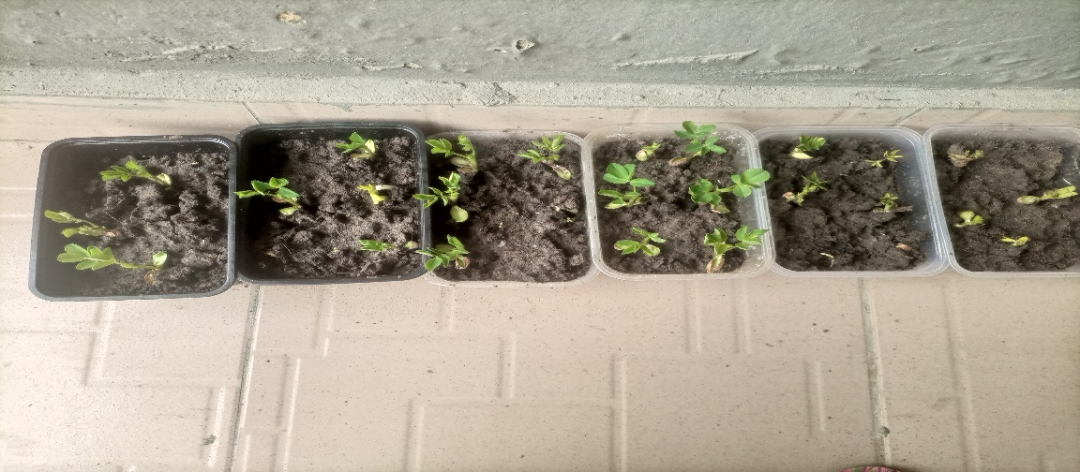

Note: from observation, the 5th day growth show the seeds are viable and suit for transplanting.

The image below show the day 8 of the seedling growth.

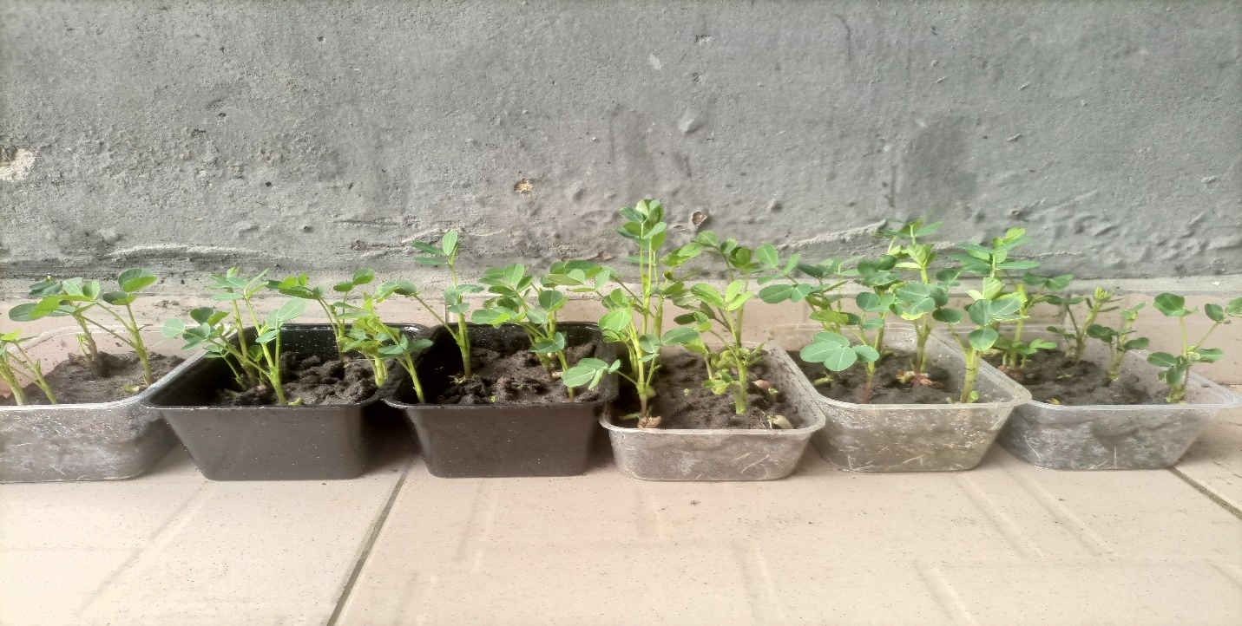

This growth show that seeds that are viable and healthy are more productive compare to unhealthy seeds are show in the stage of incubation. It is advisable to incubate the seeds you intend planting to know the viability of the seed and how the growth will follow.

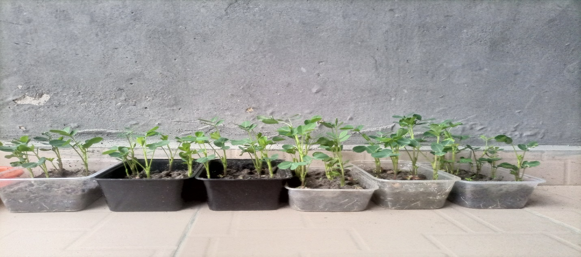

Day 9 of the growth of the groundnut seeds.

This show the remarkable growth and how it should be during the early phase of the planting season.

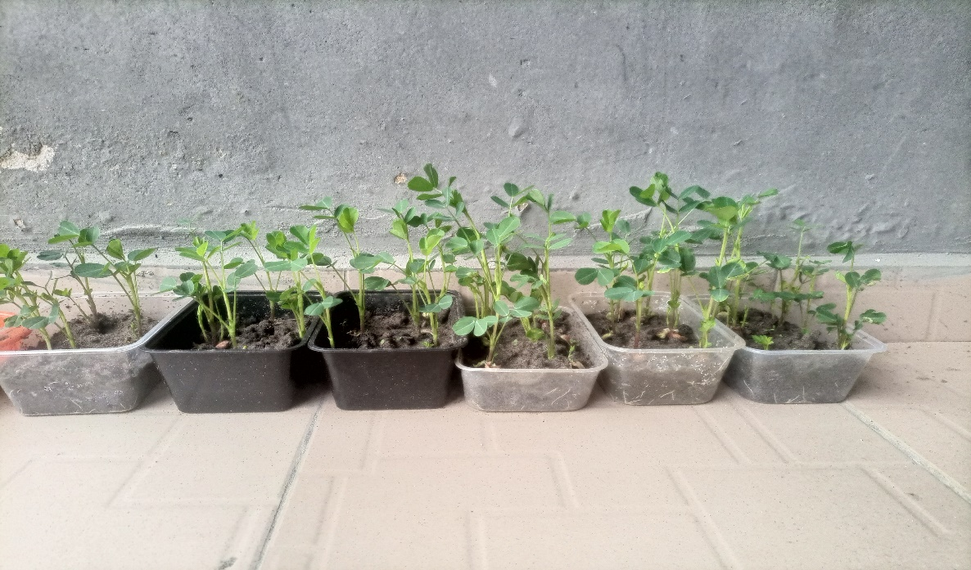

Day 10 show the growth of the groundnut seeds, ready for transplanting.

# **TRANSPLANTING PHASE**

The transplanting process takes few minutes but with careful adjustment into the sack bags. Making sure the young root of the seedling (grow plants) are well place on the soil of the sack fill with loamy soil.

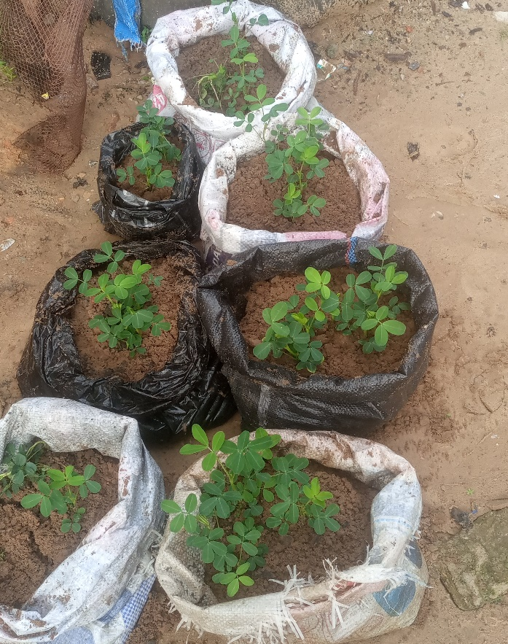

The image above is the finished process of transplanting the young groundnut plants after 16th day’s growth.